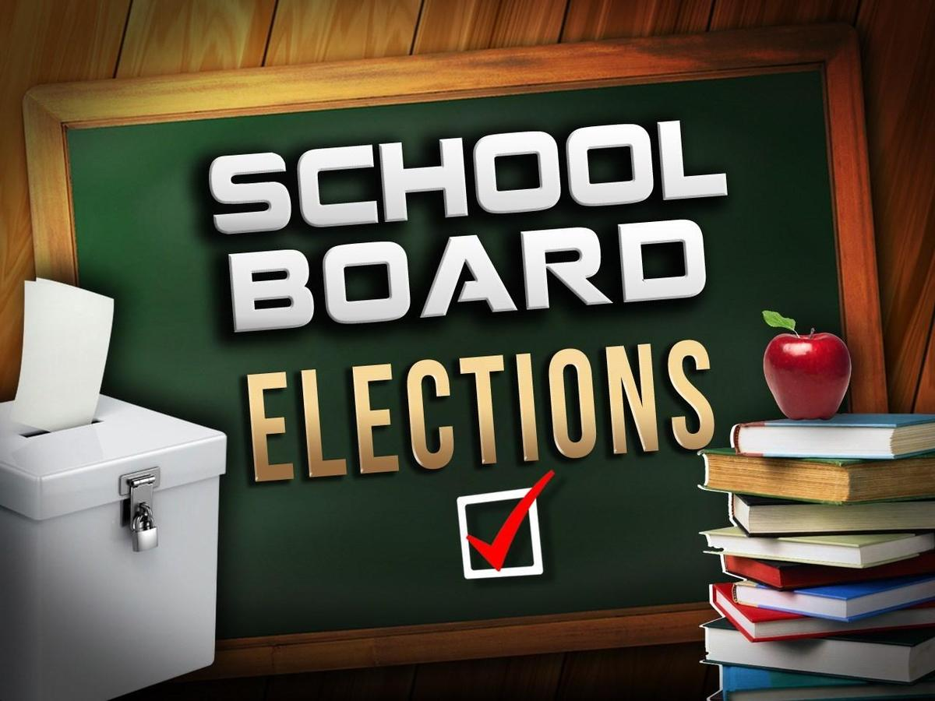

Community members interested in running for the April 6, 2021 school board election can file paperwork at the Kane County Government Center (719 S Batavia Ave., Building B, Geneva, IL 60134. December 14-21, 2020 are the dates to file paperwork. More information can be found here at the Kane County Elections Page.

